**KIOSK FOR STATE ROAD TRANSPORT**

**ANALYSIS :**

1. **Current System :**

There are no kiosks or systems provided at place or at bus stands for booking tickets, giving a feedback etc. even in cities, let alone in rural areas. Besides, there’s no consideration given for local languages like Hindi or Marathi which a vast percentage of the rural population will be comfortable with. Passengers need to travel to the nearest big bus station in order to book their tickets.

1. **Ideal Situation :**

An ideal situation would be to provide Kiosks or systems at place in bus stands itself that can help the user perform all the various functions that he would have to otherwise perform manually. Here, the user can book his tickets, view bus rides, view time it would take to reach his destinations and also be able to give a feedback.

1. **Issues that need to be considered :**
2. Requirements of passengers like booking tickets
3. Showing schedules of buses
4. Option to give feedback
5. Special buses to tourist destinations.
6. **Duty of State Road Transport Corporation :**
7. The State Road Transport Corporation needs to have a database of seats available for a particular route and for a particular bus that a passenger will look to book from its system.
8. The data needs to be stored temporarily in the memory until the ticket and receipt or acknowledgment is printed and after which it needs to be synced with the remote central database.
9. The feedback needs to be synced remotely as soon as the user enters it into the system.
10. **Initiative of the State Road Transport Corporation:**
11. The State Road Transport Corporation needs to setup kiosks at every bus station and provide internet connectivity to them.
12. Analyse the disadvantages of the kiosk system.
13. **What services can be provided :**
14. Booking of tickets along with showing the price of the ticket according to the number of passengers.
15. Feedback submission in case of any grievances or appreciation.
16. Show buses to popular places tourists would like to visit and if special buses are available for them.
17. Schedule of buses to nearby buses.
18. Show route that will be followed between a source and a destination that will be taken by buses.
19. Bus tracker can be used to track buses as to at what time buses will arrive at the bus stand.

**DESIGN:**

1. **Home Screen :**

The interface is designed in the form of Tiles on the screen format thus giving the user a view of all possible things he can do with the application without looking around and pressing for too many buttons. Images are provided coupled with text that define the action that takes place on clicking that particular tile. The arrows on the tile show the direction in which the screen moves on clicking the tile.Also, there is a dropdown provided with an option to change the language of the app.

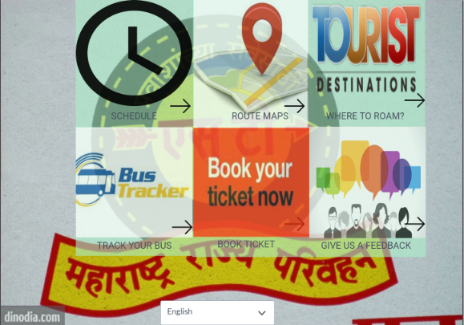

Screen 1 : English Home Screen

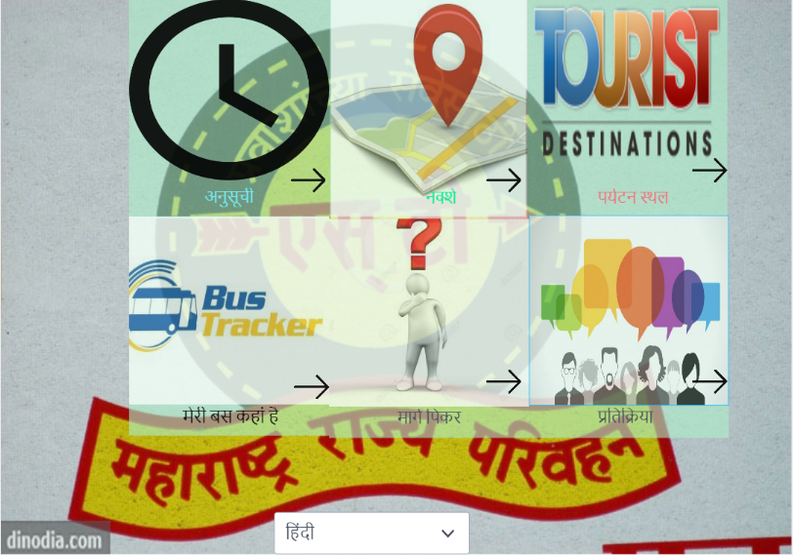Screen 2 : Hindi Home Screen

1. **Bus Schedule Screen** :

On clicking the schedule tile, there is a dropdown provided which contains the bus numbers and after the user selects the bus number, the schedule of the bus at every bus stop along the route is shown .

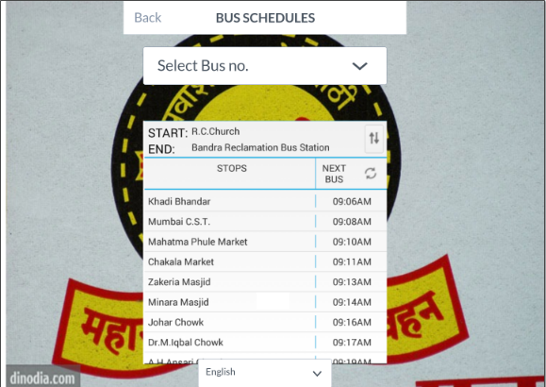

Screen 3 : Bus Schedule Screen

1. **Route Finder** :

The next tile is the “Route Finder” which helps to find the routes between a source and a destination which has to be selected after which it shows buses that the user can take and the amount of time approximately it will take to reach there. Besides, it shows the location of the bus stand with a blue dot on the map and the destination on the map with a location icon.

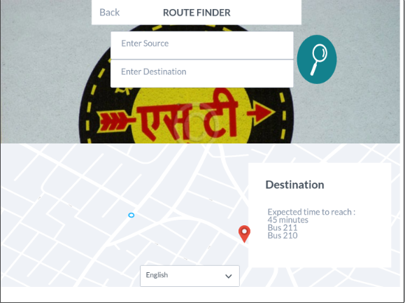

Screen 4 : Route Finder Screen

1. **Tourist Destinations** :

Clicking this tile results in showing the nearest tourist destinations and the bus numbers to take in order for the passengers to reach those places and current location as a blue circle.

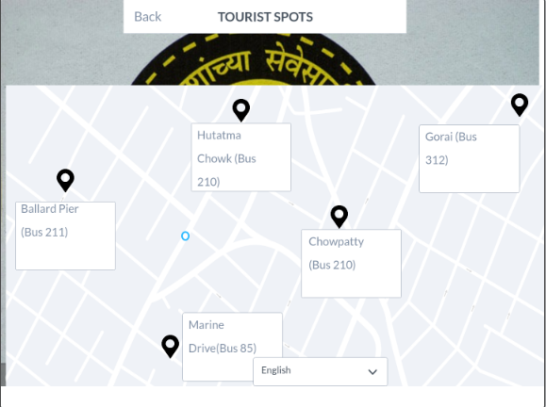

Screen 5 : Tourist Destinations

1. **Bus Tracker** :

This screen tracks the current location of the bus after the user selects the bus number from the dropdown that is provided.

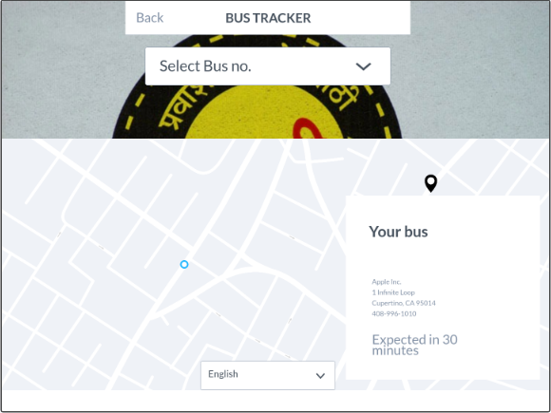

Screen 6 : Bus Tracker

1. **Book Tickets** :

This windows allows you to book tickets via the Kiosk machine by entering all details asked such as source, destination, no. of passengers and providing the smart card number.

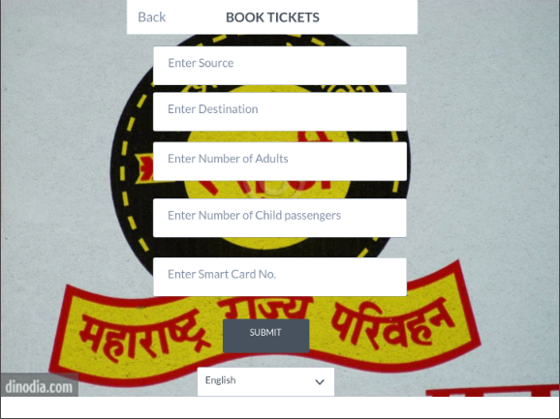

Screen 7 : Book Tickets Screen

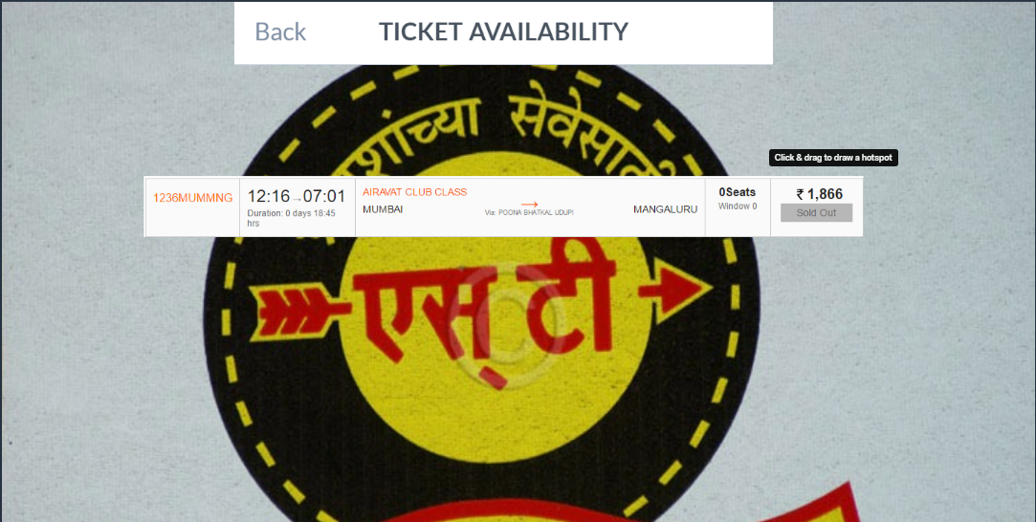

Screen 8 : Ticket Availability Screen

1. **Give Feedback Screen** :

A screen has been provided in order to provide feedback regarding the service and the app in general.

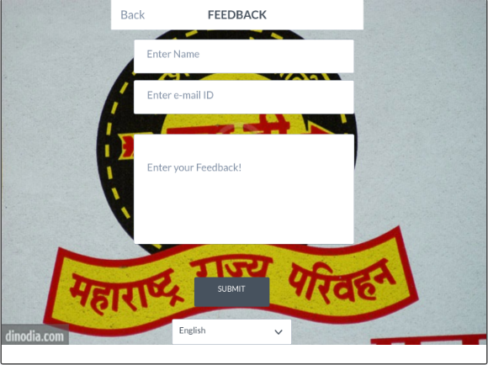

Screen 8 : Feedback Screen